**COMPUTATION OF RECTANGULAR VOLUME**

**LAB #2**

**SECTION #CC**

**SUBMITTED BY:**

**LOGAN WOOLERY**

**SUBMISSION DATE:**

**9/7/16**

# Problem

The purpose of this lab is to create a simple program that will calculate the volume of a prism with user generated values. The program must allow a user to input measurement values, then output the total volume. The objective of this lab is to learn to use basic input and output and math operations.

# Analysis

The problem states that the volume of a rectangular prism must be calculated. Therefor the problem input is a series of numbers greater than zero with no upper limit, and the output is the average of these values. The only formula necessary is the formula for the volume of a rectangular prism, length*width*height=Volume.

# Design

The problem was to create a program that will calculate volume from user inputs. Thus, the program needed to follow three general steps:

1. Get the user data.
2. Calculate the volume using the formula l*w*h=V.
3. Display the volume.

Using the above outline, the program was designed to gather user data through a scanf and assign it to a int variable. The mathematic computations were then preformed, and the result output through a printf statement.

# Testing

The first program run was a simple test of the core code structure. There were no issues with this code.

// LAB2-0.c

#include <stdio.h>

int main**(**int argc**,** char**\*** argv**[]){**

printf**(**"My name is Logan Josiah Woolery, a student in the CPRE 185 course. Todays date is 9/7/16\n"**);**

**return** 0**;**

**}**

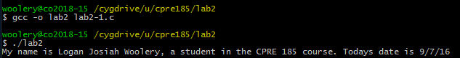

The second piece of code was a test of input/output, and arithmetic operators. There was one err when compiled, a simple typo that was easily fixed.

// LAB2-2.c

#include <stdio.h>

int main**(**int argc**,** char**\*** argv**[]){**

int x**,** y**;**

printf**(**"Enter a width:"**);**

scanf**(**"%d"**,** **&**x**);**

printf**(**"Enter a height:"**);**

scanf**(**"%d"**,** **&**y**);**

printf**(**"A %d by %d rectangle's area is %d\n"**,** x**,**y**,**x**\***y**);**

**return** 0**;**

**}**

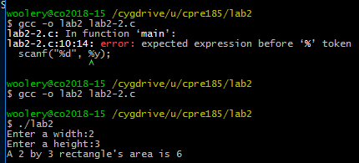

The final program was intended to solve the problem and calculate the volume from user gathered data. It performed as intended.

// LAB2-3.c

#include <stdio.h>

int main**(**int argc**,** char**\*** argv**[]){**

int x**,** y**,** z**,** vol**;**

printf**(**"Enter a width:"**);**

scanf**(**"%d"**,** **&**x**);**

printf**(**"Enter a height:"**);**

scanf**(**"%d"**,** **&**y**);**

printf**(**"Enter a depth:"**);**

scanf**(**"%d"**,** **&**z**);**

vol **=** x**\***y**\***z**;**

printf**(**"A %d by %d by %d rectangular prisms volume is %d\n"**,** x**,**y**,**z**,**vol**);**

**return** 0**;**

**}**

# Comments

In doing this lab, I learned that taking a couple seconds to double check everything can save you from having to deal with avoidable debug errors later.

# Source Code

<Use NPP Exporter to PASTE source code>

# Screen Shots

<Number the screenshots and paste here. The point of numbering the screenshots is so that you can refer to them during your discussion in the various parts above. Alternatively, you can include the screenshots in-line with the text above as part of your discussion.>